PIZZA SALES MYSQL QUERIES

1. **KIP’s**
2. **Total Revenue**

select sum(total_price) as Total_Revenue from pizza_sales

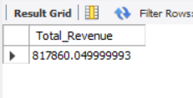

1. **Average Order Value**

SELECT SUM(total_price) / COUNT(DISTINCT order_id) as Avg_Order_Value from pizza_sales;

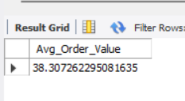

1. **Total Pizza Sold**

SELECT SUM(quantity) AS Total_Pizza_Sold from pizza_sales;

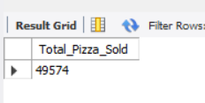

1. **Total Orders**

SELECT COUNT(DISTINCT order_id) AS Total_Order from pizza_sales;

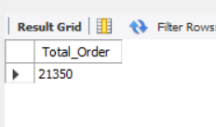

1. **Average Pizza Per Order**

SELECT SUM(quantity) / COUNT(DISTINCT order_id) as Avg_Pizzas_Per_Order FROM pizza_sales;

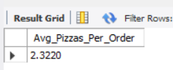

1. Top 5 Bester Sellers of Pizzas

select top 5 pizza_name, count(distinct order_id) as order_count,

sum(quantity) as amount from pizza_sales group by 1

order by 3 desc;

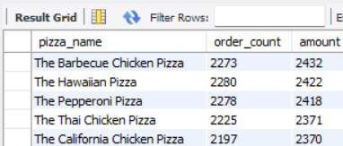

1. Top 5 % Best Sellers Pizzas By Totsl Pizza Sold

Select top 5 pizza_name, round(sum(total_price)) as Total_Revenue,

round(sum(total_price)*100/(select sum(total_price) from pizza_sales),2) as PCT_of_total_Revenue

from pizza_sales group by pizza_name

order by Total_Revenue desc;

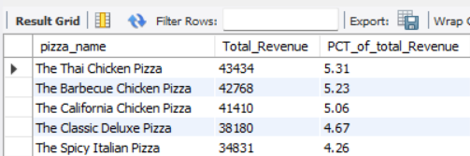

1. % Sale of Pizzas by Size

select pizza_size, round(sum(total_price),0) as Revenue_by_size from pizza_sales

group by 1

order by 2 desc;

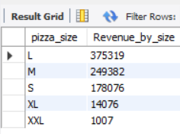

1. **% Sale of Pizzas by Category**

select pizza_size, round(sum(total_price)*100/ (select sum(total_price) from pizza_sales),2)

as Pct_revenue_by_Size from pizza_sales group by 1

order by 2 desc;

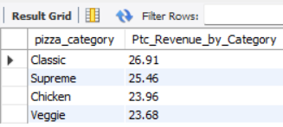

1. Daily Trend for Total Orders

select name_of_the_day, count(distinct order_id) as total_order,sum(quantity) as total_sale,

round(sum(total_price),0) as revenue_of_the_day from pizza_sales group by 1

order by 2 desc;

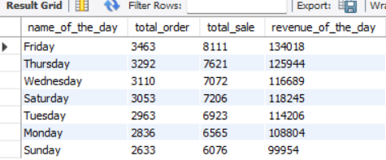

1. Weekend and Weekday Sales

select daytype, count(distinct order_id) as order_count,

round(sum(total_price),0) as revenue,

round(sum(total_price)*100/ (select sum(total_price) from pizza_sales),2) as Pct_Revenue_by_Daytype

from pizza_sales

group by 1;

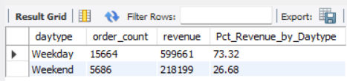

1. **Monthly Trend for orders**

select MonthName, count(distinct order_id) as order_count from pizza_sales group by 1

order by 2 desc;

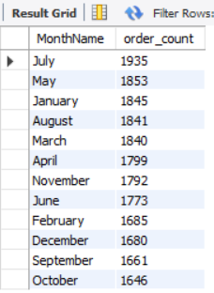

1. **% Revenue for Monthly by Total Sales**

select MonthName, count(distinct order_id) as order_count,

round(sum(total_price),0) as revenue_per_month,

round(sum(total_price)*100/ (select sum(total_price) from pizza_sales),2) as Pct_Revenue_per_month

from pizza_sales group by 1

order by 2 desc;

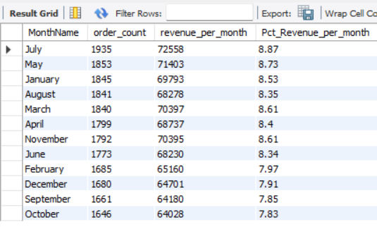

1. **Bottom top 5 Sellers by Total Pizza Sellers**

select pizza_name, count(quantity) as Total_pizza_solds from pizza_sales

group by pizza_name

order by Total_pizza_solds

limit 5;

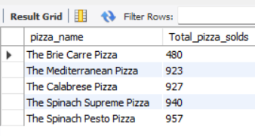

1. **Lowest performance of months**

select MonthName, count(quantity) as Sales_per_month from pizza_sales

group by MonthName

order by Sales_per_month

limit 3;

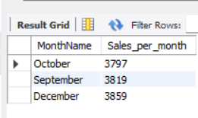

## Note: Here we can perform many other function like Month, Quarter, Week filters by using where clause.